Tortoise SVN

Repository
Subversion is a centralized system for sharing information. At its core is a repository, which is a central store of data. The repository stores information in the form of a filesystem tree - a typical hierarchy of files and directories. Any number of clients connect to the repository, and then read or write to these files. By writing data, a client makes the information available to others; by reading data, the client receives information from others

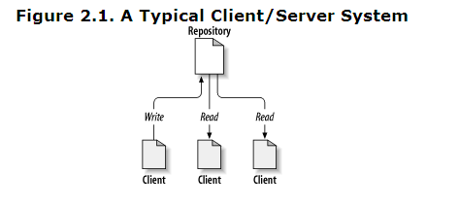

Working copy
A Subversion working copy is an ordinary directory tree on your local system, containing a collection of files. You can edit these files however you wish, and if they're source code files, you can compile your program from them in the usual way. Your working copy is your own private work area: Subversion will never incorporate other people's changes, nor make your own changes available to others, until you explicitly tell it to do so.
After you've made some changes to the files in your working copy and verified that they work properly, Subversion provides you with commands to publish your changes to the other people working with you on your project (by writing to the repository). If other people publish their own changes, Subversion provides you with commands to merge those changes into your working directory (by reading from the repository).
A working copy also contains some extra files, created and maintained by Subversion, to help it carry out these commands. In particular, each directory in your working copy contains a subdirectory named .svn, also known as the working copy administrative directory. The files in each administrative directory help Subversion recognize which files contain unpublished changes, and which files are out-of-date with respect to others' work.
• Trunk would be the main body of development, originating from the the start of the project until the present.
• Branch will be a copy of code derived from a certain point in the trunk that is used for applying major changes to the code while preserving the integrity of the code in the trunk. If the major changes work according to plan, they are usually merged back into the trunk.

Icon Overlay
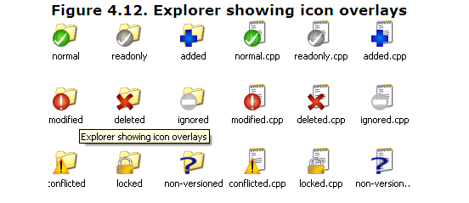
A fresh checked out working copy has a green checkmark as overlay. That means the Subversion status is normal.

As soon as you start editing a file, the status changes to modified and the icon overlay then changes to a red exclamation mark. That way you can easily see which files were changed since you last updated your working copy and need to be committed.

If during an update a conflict occurs then the icon changes to a yellow exclamation mark.

If you have set the svn:needs-lock property on a file, Subversion makes that file read-only until you get a lock on that file. Such files have this overlay to indicate that you have to get a lock first before you can edit that file.

If you hold a lock on a file, and the Subversion status is normal, this icon overlay reminds you that you should release the lock if you are not using it to allow others to commit their changes to the file

This icon shows you that some files or folders inside the current folder have been scheduled to be deleted from version control or a file under version control is missing in a folder.

The plus sign tells you that a file or folder has been scheduled to be added to version control.

The bar sign tells you that a file or folder is ignored for version control purposes. This overlay is optional.
This icon shows files and folders which are not under version control, but have not been ignored

Checking out Working Copy
To obtain a working copy you need to do a checkout from a repository
Select a directory in windows explorer where you want to place your working copy. Right click to pop up the context menu and select the command TortoiseSVN → Checkout..., which brings up the following dialog box:
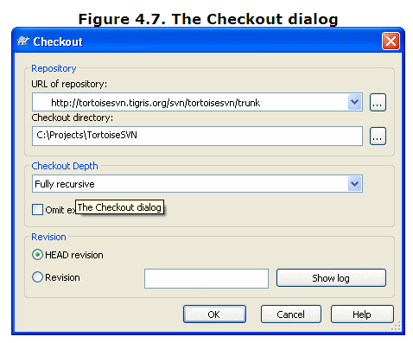
Checkout Depth
You can choose the depth you want to checkout, which allows you to specify the depth of recursion into child folders. If you want just a few sections of a large tree, You can checkout the top level folder only, then update selected folders recursively
- Fully recursive
  - Checkout the entire tree, including all child folders and sub-folders.
- Immediate children, including folders
  - Checkout the specified directory, including all files and child folders, but do not populate the child folders.
- Only file children
  - Checkout the specified directory, including all files but do not checkout any child folders.
- Only this item
  - Checkout the directory only. Do not populate it with files or child folders.
- Working copy
  - Retain the depth specified in the working copy. This option is not used in the checkout dialog, but it is the default in all other dialogs which have a depth setting.
- Exclude
  - Used to reduce working copy depth after a folder has already been populated. This option is only available in the Update to revision dialog.

Committing Your Changes To The Repository
Sending the changes you made to your working copy is known as committing the changes. But before you commit you have to make sure that your working copy is up to date. You can either use TortoiseSVN → Update directly. Or you can use TortoiseSVN → Check for Modifications first, to see which files have changed locally or on the server
If your working copy is up to date and there are no conflicts, you are ready to commit your changes. Select any file and/or folders you want to commit, then TortoiseSVN → Commit....
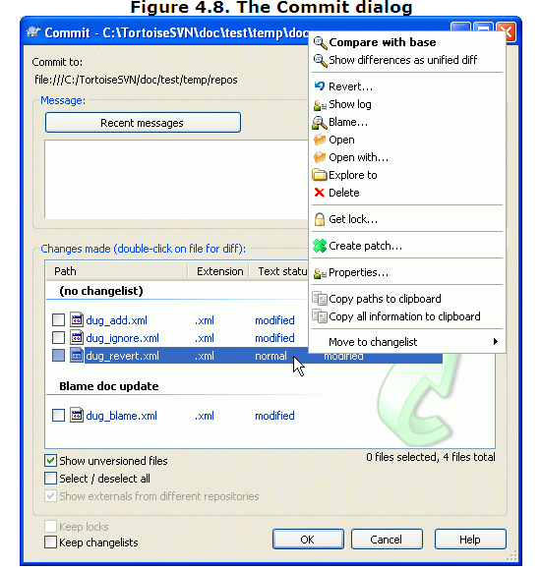
The commit dialog will show you every changed file, including added, deleted and unversioned files. If you don't want a changed file to be committed, just uncheck that file. If you want to include an unversioned file, just check that file to add it to the commit

Be sure to enter a log message which describes the changes you are committing. This will help you to see what happened and when, as you browse through the project log messages at a later date

Update Your Working Copy With Changes From Others
Periodically, you should ensure that changes done by others get incorporated in your local working copy. The process of getting changes from the server to your local copy is known as updating. Updating may be done on single files, a set of selected files, or recursively on entire directory hierarchies. To update, select the files and/or directories you want, right click and select TortoiseSVN → Update in the explorer context menu
A window will pop up displaying the progress of the update as it runs. Changes done by others will be merged into your files, keeping any changes you may have done to the same files. The repository is not affected by an update
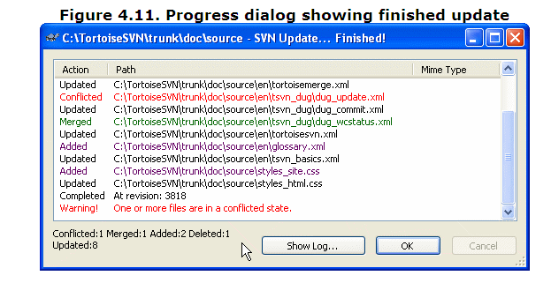
The progress dialog uses color coding to highlight different update actions
- Purple
  - New item added to your WC.
- Dark red
  - Redundant item deleted from your WC, or missing item replaced in your WC.
- Green
  - Changes from repository successfully merged with your local changes.
- Bright red
  - Changes from repository merged with local changes, resulting in conflicts which you need to resolve.
- Black
  - Unchanged item in your WC updated with newer version from the repository.

Resolving Conflicts
There are two kinds of conflicts
File conflicts
- A file conflict occurs if two (or more) developers have changed the same few lines of a file.
- To resolve file conflicts go to each conflicted file and find the difference with the previous revision. According to changes observer make the changes into that file and select the option to resolve the conflicted files.
- Commit the working copy.
Tree conflicts
A tree conflict occurs when a developer moved/renamed/deleted a file or folder, which another developer either also has moved/renamed/deleted or just modified. There are many different situations that can result in a tree conflict, and all of them require different steps to resolve the conflict

Adding New Files And Directories
If you created new files and/or directories during your development process then you need to add them to source control too. Select the file(s) and/or directory and use TortoiseSVN → Add.
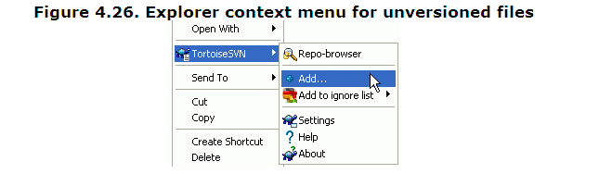
After you added the files/directories to source control the file appears with a added icon overlay which means you first have to commit your working copy to make those files/directories available to other developers. Adding a file/directory does not affect the repository!

Deleting files and folders
Use TortoiseSVN → Delete to remove files or folders from subversion

When you TortoiseSVN → Delete a file, it is removed from your working copy immediately as well as being marked for deletion in the repository on next commit. The file's parent folder shows a “deleted” icon overlay until you commit the change. You can get the file back using TortoiseSVN → Revert on the parent folder

If you want to delete an item from the repository, but keep it locally as an unversioned file/folder, use Extended Context Menu → Delete (keep local). You have to hold the Shift key while right clicking on the item in the explorer list pane (right pane) in order to see this in the extended context menu.

Ignoring Files And Directories
In most projects you will have files and folders that should not be subject to version control. These might include files created by the compiler, *.obj, *.lst, maybe an output folder used to store the executable. Whenever you commit changes, TortoiseSVN shows your unversioned files, which fills up the file list in the commit dialog
The best way to avoid these problems is to add the derived files to the project's ignore list

If you right click on a single unversioned file, and select the command TortoiseSVN → Add to Ignore List from the context menu, a submenu appears allowing you to select just that file, or all files with the same extension. If you select multiple files, there is no submenu and you can only add those specific files/folders.
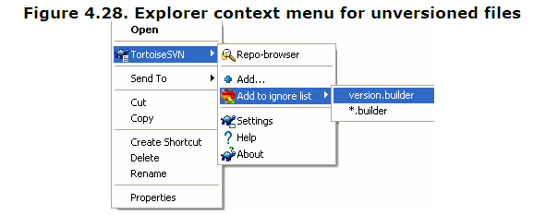
you want to remove one or more items from the ignore list, right click on those items and select TortoiseSVN → Remove from Ignore List

Undo Changes
If you want to undo all changes you made in a file since the last update you need to select the file, right click to pop up the context menu and then select the command TortoiseSVN → Revert.
A dialog will pop up showing you the files that you've changed and can revert. Select those you want to revert and click on OK.
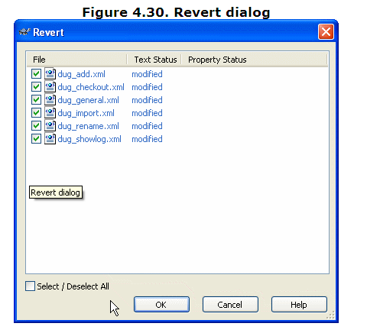

Cleanup
If a Subversion command cannot complete successfully, perhaps due to server problems, your working copy can be left in an inconsistent state. In that case you need to use TortoiseSVN → Cleanup on the folder. It is a good idea to do this at the top level of the working copy

Create branches for your project
One of the features of version control systems is the ability to isolate changes onto a separate line of development. This line is known as a branch. Branches are often used to try out new features without disturbing the main line of development with compiler errors and bugs. As soon as the new feature is stable enough then the development branch is merged back into the main branch (trunk).
- Open your trunk folder.
- Right click on trunk
- Select option “Tortoise SVN”
- Select option “Branch/tag option”
- Enter URL as follows
- http:// 220.227.236.28/svn/YOUR-PROJECT-NAME/branches/YOUR-NEW-BRANCH-NAME
- Enter log message as follow
- “Created new branch for the [Task NAME]”
- Click on ok button
- After creating branch successfully go to “branch” folder
- Create a new folder (named as YOUR-NEW-BRANCH-NAME)
- Check out this newly created folder with above “Branch” URL

Merge Trunk into Branch
- Go to Trunk folder
- Right click on Trunk folder
- Select option “SVN Update”
- Go to Branch
- Right click on branch
- Select option “Tortoise SVN”
- Select merge option
- Select “Merge a range of revision” option and click on next button
- Select Trunk URL from “URL to merge from” field(URL To Merge From Should be “Trunk” URL)
- Enter range of revision in “Revision Range to merge” field i.e. [Your previous Merge Revision]-Head
- Click on next and click on “Merge” button
- After merging commit all the files and add comment as follows
- E.g. merged trunk at revisions 6876-6897

Note: If you face any conflicts during merging then select resolve later option.

Handling Conflicts during Merge
Merging does not always go smoothly. Sometimes there is a conflict, and if you are merging multiple ranges, you generally want to resolve the conflict before merging of the next range starts. TortoiseSVN helps you through this process by showing the merge conflict callback dialog
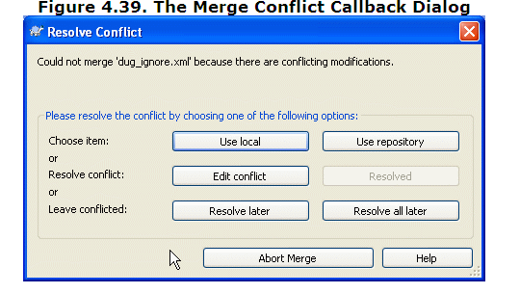

When a conflict occurs during the merge, you have three ways to handle it.
- You may decide that your local changes are much more important, so you want to discard the version from the repository and keep your local version. Or you might discard your local changes in favour of the repository version. Either way, no attempt is made to merge the changes - you choose one or the other.
- Normally you will want to look at the conflicts and resolve them. In that case, choose the Edit Conflict which will start up your merge tool. When you are satisfied with the result, click Resolved.
- The last option is to postpone resolution and continue with merging. You can choose to do that for the current conflicted file, or for all files in the rest of the merge. However, if there are further changes in that file, it will not be possible to complete the merge
If you do not want to use this interactive callback, there is a checkbox in the merge progress dialog Merge non-interactive. If this is set for a merge and the merge would result in a conflict, the file is marked as in conflict and the merge goes on. You will have to resolve the conflicts after the whole merge is finished

